**Golf Fore CASA**



4-person Golf tournament

Monday, October 6, 2025

Registration 7:30am – Shotgun Start 9am

Merced Golf and Country Club

$600 foursome includes 18 holes of golf, cart, and lunch.

For more information, call the CASA office at 209-722-2272, Carol at 209-769-7445 or Cathie at 209-506-4224 OR email clancaster@mercedcasa.org

Please make checks payable to CASA of Merced County

Write golf tournament on the check

|  |  |  |  |  |
| --- | --- | --- | --- | --- |
|  | Name | Address | Phone | Email |
| Player 1 |  |  |  |  |
| Player 2 |  |  |  |  |
| Player 3 |  |  |  |  |
| Player 4 |  |  |  |  |

Please return this form with payment to:

CASA of Merced County

2824 Park Ave Suite A

Merced, CA 95348

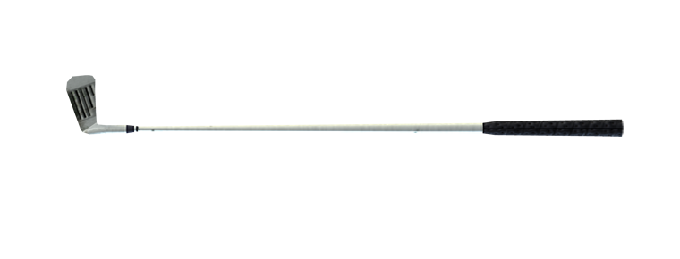

Our mission is to recruit, train, supervise and retain volunteers whose job it is to advocate and be the voice for children in foster care. Your support of Golf Fore CASA will help us retain and provide a CASA volunteer to one of almost 600 abandoned, abused and neglected foster children in Merced County.