CCAI Contact: Kate McLean
Congressional Coalition on Adoption Institute kate@ccainstitute.org (p) 202-544-8500 ext. 11

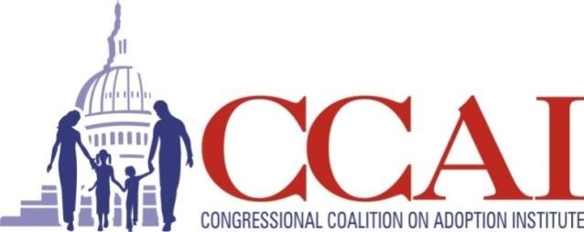
FOR IMMEDIATE RELEASE
Congressman Jim Costa Celebrates CASA of Merced County as an Angels in Adoption®
Honoree To Be Recognized at National Virtual Event in 2020

[Location] – [Date] – Congressman Jim Costa will celebrate CASA of Merced County as a 2020 Angels in Adoption® Honoree for their outstanding advocacy for foster care issues. The Congressional Coalition on Adoption Institute (CCAI), which coordinates the Angels in Adoption® Program, will honor CASA of Merced County on September 30 in a virtual gala.

CASA of Merced County is being honored for the work they do advocating for the abandoned, abused and neglected children in the foster care system. A CASA volunteer is a sworn officer of the court who completes over 30 hours of training to represent the best interest of the foster children they serve. CASA of Merced County is celebrating ten years in 2020 serving the foster youth in Merced County.

The Angels in Adoption® Program is CCAI’s signature public awareness event and provides an annual opportunity for all members of the U.S. Congress to honor the good work of their constituents who have enriched the lives of children and families in the United States and abroad. This year, more than 95 Angels are being honored through the 22nd Annual Angels in Adoption® Program.

“The Angels in Adoption program gives a platform to the families, advocates, and experts who so often serve quietly behind the scenes yet make a huge impact on behalf of children and families. Together with the Adoption Caucus, we are thrilled to shine a light on the extraordinary work of our Angels,” said CCAI’s Executive Director, Nancy Kay Blackwell.

In addition to the Angel honorees from around the country, CCAI also honors a select number of National Angels in Adoption® whose contributions have had a national impact. The 2020 National Angels are Magnolia Earl & Family (Gerber’s 2020 & First Adopted Spokesbaby), Todd Tilghman (adoptive parent and 2020 Winner of The Voice), Miranda & Luke Caldwell (adoptive parents and stars on HGTV’s Boise Boys), and This Is Us (award-winning family drama television show with adoption and foster care storylines).

Past National Angels include Muhammad Ali, First Lady Laura Bush, Kristin Chenoweth, Scott Fujita, Deborra-lee Furness, Katherine Heigl and Josh Kelley, Patti LaBelle, Ne-Yo, Rhea Perlman, Shonda Rhimes, Korie and Willie Robertson, Al Roker, Jane Seymour, Sean Anders, Sean and Leigh Anne Tuohy, Bruce Willis, Nia Vardalos, Bill Klein and Jen Arnold, Scott and Tracie Hamilton, Connie Britton, Rachel Crow, CBS Studios, Extreme Makeover: Home Edition, NVIDIA, Hallmark Channel, and PEOPLE Magazine.

CCAI is a 501(c)(3) nonpartisan organization dedicated to raising awareness about children and youth in the United States and around the world in need of permanent, safe, and loving homes. Founded in 2001 by the co-chairs of the bicameral, bipartisan adoption caucus – the Congressional Coalition on Adoption, one of Congress’ premier caucuses – CCAI works with the caucus to eliminate policy barriers that hinder children from realizing their basic right of a family and more effectively raise congressional and public awareness about adoption, foster care, and child welfare.

CCAI does not receive any government funding and relies on the generous support of foundations, corporations, and individuals to accomplish this mission. The 22nd Annual Angels in Adoption Program would not be possible without our Platinum Partners: Arnold & Porter, Carlson Family Foundation, and Dave Thomas Foundation for Adoption; and our Gold Partners: American Council of Life Insurers, Brownstein Hyatt Farber Schreck, Casey Family Programs, and Retail Orphan Initiative.

To register for the virtual gala on September 30 at 8PM EST, please visit bit.ly/2020angelsgala. For more information, visit www.ccainstitute.org.

