Merced County Foster Youth Resource Fliers

Emergency/Legal Services & Information
911
Merced Police Department
https://www.cityofmerced.org/departments/police

Merced County Sheriff’s Department
https://www.co.merced.ca.us/87/Sheriffs-Office

Merced County Courthouse
https://www.mercedcourt.org/

Covid-19 Information:
MercedCounty Covid-19 Updates
https://www.countyofmerced.com/3350/Coronavirus-Disease-2019
Ted Talks & Information
https://www.ted.com/search?q=Covid-19
State Hotline: (833)544-2374

CNN Special- Sesame Street To Explain Covid-19 To Kids
https://www.fatherly.com/news/the-sesame-street-gang-will-explain-covid-19-to-kids-in-cnn-special/?utm_source=facebook&fbclid=IwAR0-mwmENZjalOinnywHxOwf7GsuUqKsxDvoaC4VFFN8dDXgdPYKoJuKJv4
Health Information:
Dignity Health Free Virtual Visits for Coronavirus Symptoms
https://www.dignityhealth.org/cov19-video-visits
Golden Valley Health Centers
https://www.gvhc.org/
Covered California Application Page

https://www.healthforcalifornia.com/covered-california/application?gclid=cjwkcajwnir1braweiwa6gpwnv3ecchvp1m5xuwnycovps37zfmuubhszx8a2-vjgbcq9mi4echsahocxj8qavd_bwe

Dental Providers Offering Emergency Services
https://dental.dhcs.ca.gov/Beneficiaries/Denti-Cal/COVID-19_Emergency_Locations/
Food/Supplies Assistance:
Merced County Human Services Agency

https://www.co.merced.ca.us/74/Human-Services-Agency

Challenged Family Resource Center

http://www.challengedfrc.org/

Community Action Agency Website

https://www.mercedcaa.com/

Pop Up People’s Pantry
Every Saturday at 1pm
936 W. 18th St. Merced

Love Inc.
Upon Request: Call 209-383-7034
Salvation Army
Monday-Friday 9am-1pm
1440 W. 12th St., Merced
Calvary Assembly of God Church
Upon Request: Call 209-723-2395
1021 R St., Merced
United Methodist Church
Upon Request: Call 209-722-5777
899 Yosemite Parkway, Merced
Bethel Community Church
415 I St. Los Banos
Lifeline Community Center
Upon Request for Winton residence: 209-358-6939
7081 N. Winton Way, Winton
Emmanuel Baptist Church
1310 Main Street, Livingston

UC Merced Food Pantry
3rd Friday every month 10am-2pm
Tri-College (G St. entrance)
Merced County Food Bank
Monday-Friday, 7am-3pm
2000 W. Olive Ave., Merced
https://mmcfb.org/

Merced Catholic Charities

https://ccdof.org/career-and-education-center-merced/

School Lunch Pick up (kids 18 years and under)
Information subject to change- please check with your school district for location and times.
MUHSD- Monday-Friday 11am-12
Atwater District- Monday & Wednesday 11am-12:30
Ballico-Cressey Distric-t Monday-Friday 10:30am-12:30
Delhi District- Monday-Friday 9am-11:30
Dos Palos District- Monday-Friday 10am-12
El Nido District- Monday & Wednesday 8:30am-11:30
Hilmar District- Monday & Thursday 10am-11
LeGrand District- Monday-Friday 8am-9:30
Livingston District- Monday & Thursday 11am-12
Los Banos District- Monday-Friday 11am-1
Merced City District- Monday, Wednesday, & Thursday 9am-1
Planada District- Monday-Friday 8am-9
Snelling-Merced Falls District- Monday- Friday 8am-9 & 12pm-1
Winton District- Monday & Wednesday 11am-12:30

Cal Fresh Application Page

https://www.getcalfresh.org/?source=g2&gclid=CjwKCAjwnIr1BRAWEiwA6GpwNT3bI87q2konjXkI8fc_vCL4_GXmK3RvbJRygFrUgZe_ilWNXFPpQxoC65AQAvD_BwE

Educational Assistance:
GoPeer is giving 1,000 free hours of tutoring to students in the area (2 free hours per family). Enter the code FREE120 (*use all capital letters) when creating your free parent or student account.
https://gopeer.org/profile/5e779ece4ff64a1fd78a4191?referrer=DExRn6
Merced County Office of Education
https://www.mcoe.org/

Merced Union High School District
http://www.muhsd.org/
MCOE EMPOWER Program
https://mcoe.org/deptprog/edservices/CandC/empower/Pages/empower.aspx

MCOE's Head Start Program

https://mcoe.org/deptprog/earlyed/HeadStart/Pages/default.aspx

Merced County Library

https://www.co.merced.ca.us/77/Library

Merced College

https://www.mccd.edu/

Merced College Next Up Program

Mccd.edu/resources/NextUp

UC Merced

https://www.ucmerced.edu/

MCOE Website
https://www.mcoe.org/Pages/Home.aspx
http://www.muhsd.org/

Merced County School District Websites
Atwater District: https://www.aesd.edu/
Ballico-Cressey District: http://www.ballicocressey.com/
Delhi District: https://www.delhi.k12.ca.us/
Dos Palos District: https://www.dpol.net/
El Nido District: https://www.elnidoschool.org/
Gustine District: https://www.gustineusd.org/
Hilmar District: https://www.hilmarusd.org/
Le Grand District: https://www.legrand.k12.ca.us/
Livingston District: http://www.livingstonusd.org
Los Banos District: https://www.losbanosusd.org/
McSwain District: https://www.mcswain.k12.ca.us/
Merced City District: https://www.mcsd.k12.ca.us/
Merced River District: https://www.mrusd.us/
Plainsburg District: https://www.plainsburg.k12.ca.us/
Planada District: https://www.planada.org/
Snelling-Merced Falls District: http://www.snelling.k12.ca.us/
Weaver District: https://www.weaverusd.org/
Winton District: http://www.winton.k12.ca.us/

Mental & Behavioral Health Information/Support:
Merced County Mental and Behavioral Health Services
https://www.co.merced.ca.us/78/Behavioral-Health-and-Recovery-Services

Sierra Vista Mental Health Services
https://www.sierravistacares.org/
MCOE Social Skills Calendars
https://www.mcoe.org/deptprog/earlyed/CK/Pages/Social-Skills-Calendars.aspx
Parents Helping Parents Website
https://www.php.com/
Promoting Children's Resilience
https://www.childtrends.org/publications/ways-to-promote-childrens-resilience-to-the-covid-19-pandemic
Stress Relief Playbook
https://covid19.ca.gov/pdf/caregivers_and_kids_california_surgeon_general_stress_busting_playbook_draft_v2_clean_ada_04072020v2.pdf
Handling Challenging Behavior
https://www.yolokids.org/handling-your-childs-challenging-behaviors-every-age
Emotional Support
https://covid19.ca.gov/resources-for-emotional-support-and-well-being/
Parent & Youth Hotline Support
https://www.childhelp.org/childhelp-hotline/
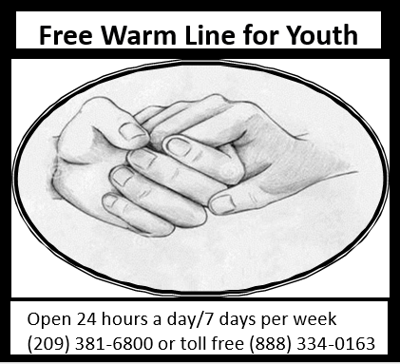
Parent Website
https://www.parents.com/
CDC- Stress and Coping with Covid-19 web pagehttps://www.cdc.gov/coronavirus/2019-ncov/daily-life-coping/managing-stress-anxiety.html
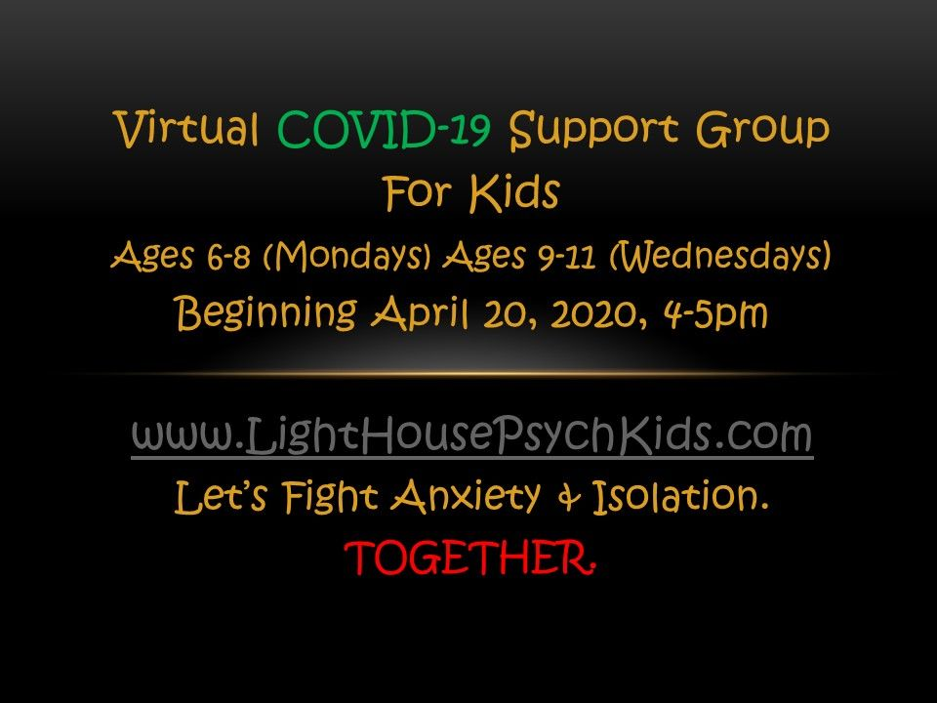
Abuse Support:
24 Hour Child Abuse Hotline (Merced County): 209-385-3104
Valley Crisis
https://www.valleycrisiscenter.org/
Article & Information Links Regarding Domestic Violence
https://news.yahoo.com/domestic-violence-growing-wake-coronavirus-121146632.html
https://www.apa.org/topics/covid-19/domestic-violence-child-abuse
https://victims.ca.gov/victims/issues/domesticviolence/
https://sanctuaryforfamilies.org/wp-content/uploads/2020/03/Safety-Plan-Flyer.pdf
https://www.cpedv.org/domestic-violence-organizations-california
https://covid19.ca.gov/img/wp/ipv-programs-final.pdf
National Domestic Violence Hotline
https://www.thehotline.org/
http://www.nationalparenthelpline.org/
https://safeandsound.org/for-parents/get-help-now/
https://familypaths.org/
https://calyouth.org/

Report Child Abuse in California (by County)
https://www.cdss.ca.gov/reporting/report-abuse/child-protective-services/report-child-abuse
Child Care Assistance:

