May 20, 2024

CASA of Merced County is excited to announce that sponsorships are available for our 2024 Golf Fore CASA tournament held at the beautiful Merced Golf and Country Club in Merced on Monday, July 15, 2024. This promises to be a day filled with fun, golf, refreshment, prizes and more. Last year we had a full field and we expect to sell out quickly this year as well.

Our mission is to advocate for the best interests of abused and neglected children within the court system. Your support of Golf Fore CASA will help us train and provide a CASA volunteer to one of almost 600 abandoned, abused and neglected foster children in Merced County.

There are several levels of tax-deductible sponsorship opportunities available:

4 Platinum Sponsors $5,000

8 Gold Sponsors $2,500

1 Cart Sponsor $2,000

Unlimited Two Hole Sponsor $500

Unlimited One Hole and Table Sponsor $250

Unlimited One Hole Sponsor $150

Foursomes $600

Some sponsorships are limited; I hope you will want to commit early to ensure your company or organizations name is on our event literature.

Please consider sponsoring our 2024 CASA of Merced County Golf Fore CASA and help us serve as many children as possible. Each sponsorship includes a unique package and a chance to promote your business while helping CASA put a smile on the face of an abused or neglected foster child.

Thank you for your support and I hope we see you at Merced Golf and Country Club on July 15!

Sincerely,

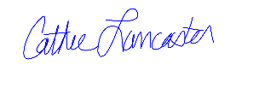

Cathie Lancaster,

Executive Director,

CASA of Merced County

P.S. Did you know?

There are almost 600 children in foster care in Merced County.

44% of children in foster care do not graduate from high school.

40% of former foster youth become incarcerated; 70% of prisoners were former foster youth.

Sponsorship Levels

4 Platinum Sponsors

* 1 Foursome includes Golf and Lunch
* Platinum Sponsor Tournament Sponsor Signage at Registration (Banner)
* Signage at 1st Tee Box and 18th Green
* CASA website and Social Media link as Tournament Title Sponsor
* Logo on CASA website and Social Media

8 Gold Sponsors

* 1 Foursome – Golf and Lunch
* Gold Sponsor Tournament Title Sponsor Signage at Registration (Banner)
* Signage one Tee Box
* Logo on CASA website and Social Media

1 Cart Sponsor - Sponsors all tournament carts

* Sponsor Signage at Registration (Banner)

Unlimited Two Hole Sponsor

* Signage on two tee boxes
* Table recognition

Unlimited One Hole and Table Sponsor

* Signage on one Tee Box
* Table recognition

Unlimited Hole Sponsors

* Signage on one Tee Box

General Donation to CASA

* Event Recognition

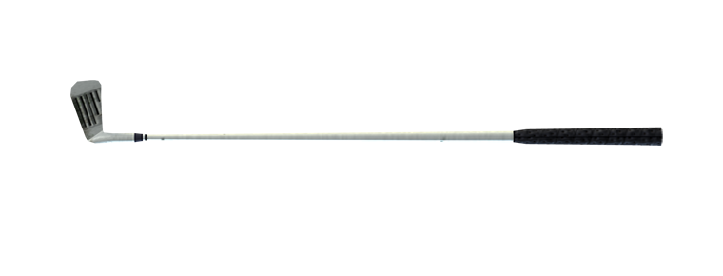

Please return this form with payment to:

CASA of Merced County

2824 Park Ave Suite A

Merced, CA 95348

For questions call 209-722-2272